|  |
| --- |
| **Exercises from old exams to chapters in B & W.** |

|  |
| --- |
| **Chapter 14 AD AS** |

**Exercise 1**

Consider an aggregate supply and aggregate demand model:

Use the model to analyze the effect of an expansionary fiscal policy under fixed exchange rates

1. in the short run and
2. in the long run.
3. Consider the situation in point (i); what is the difference from the same situation in a Mundell Fleming framework?

**Exercise 2**

1. Draw and explain the AD-AS model (aggregate supply - aggregate demand) under flexible exchange rates.
2. Use the AD-AS model to explain what will happen to the economy in the short run and in the long run, if the central bank lowers its inflation target (contractionary monetary policy) under flexible exchange rates.

**Exercise 3**

a) Explain how the AD curve can be derived from the Mundell Fleming model under fixed exchange rates.

b) Explain by using the AS AD framework how a country can reduce inflation.

**Exercise 4**

1. Use the AD-AS model to describe an adverse demand shock and discuss the use of fiscal – or monetary policy tools to restore the economy.

**Exercise 5**

Explain by using the AS-AD framework the long run effect of a monetary expansionary policy if flexible exchange rates.

**Exercise 6**

Explain by using the AD-AS framework the effect of an expansionary monetary policy under flexible exchange rates. Refer to fig 2 if desired.

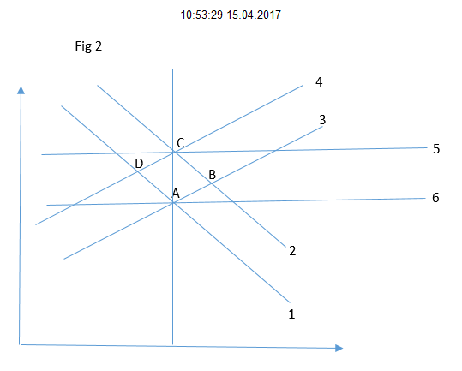

**Exercise 7**

1. Define the AD curve in an AD-AS model.
2. Why is the slope of the AD curve different when moving from the short to the long run under fixed exchange rates?
3. Explain by using the AD-AS framework the effect of an expansionary monetary policy under fixed exchange rates.
4. Explain by using the AD-AS framework the effect of a devaluation.
5. Use economic theory to give reasons why a country with fixed exchange rates experience their currency to depreciate in relation to other countries.